INNWATER’S CITIZEN ENGAGEMENT GUIDANCE FORM
GENERAL RECOMMENDATIONS
This form is intended to guide Pilot Sites in the process of gathering and analysing data to set a Citizen Engagement Roadmap. In order to effectively plan their engagement activities and meetings, PS are recommended to:
- Review the theoretical framework for citizen engagement presented as D3.2. The report provides a synthetic overview of the key questions that PS will need to address (why, what for, who, how), as well as references that can support PS to further substantiate their assessment of citizen engagement according to the local context and specific objectives.

- Review the ongoing work undertaken under WP2 Water governance for sustainability and resilience. The enhanced water governance assessment tool (D2.1) and the framework validation and future governance recommendations (D2.3) will provide PS with the water governance conceptual, methodological, and practical foundations on which citizen engagement will take place.

- Use this three-step form to progress towards setting a Citizen Engagement Roadmap. Each step consists of a set of questions that PS need to address before moving on to the following phase. The PS can work on each step through internal meetings, InnWater workshops, brainstorming exercises, interviews, etc. The final output of the form should be a completed Citizen Engagement Roadmap. A template is provided at the end of the form (Figure 1).

STEP 1. PILOT SITE INTERNAL ASSESSMENT
PROBLEM: what is citizen engagement for? | E.g. water pricing, education, awareness
EXPERIENCE: What activities are you already conducting with/for local communities in relation to water? How do they relate/respond to the problem? | E.g. neighbourhood meetings to inform/raise awareness, citizen science in connection to water quality and quantity.
RIVER BASIN WATER FORUM: Is constituting a RBWF an objective? What are the expected outcomes of this RBWF? How do they relate to citizen engagement? | E.g. creating a RBWF as a long term objective to trigger citizen engagement and consolidate the participation of all actors in the Quintuple Helix
TIMELINE: What is the timeline for citizen engagement? | E.g. starting implementation within InnWater’s timeline
RESOURCES: Do you have capacity to support citizen engagement activities? | E.g. additional financial support will be necessary to complete the roadmap

STEP 2. LOCAL COMMUNITY ENGAGEMEMENT ASSESSMENT
DEMOGRAPHICS: What are the demographics of the basin affected area? Population, age, gender, ethnic diversity, religion, income, economic activity. | E.g. link to local
CONNECTEDNESS AND REPRESENTATIVENESS: how connected/networked is the local community? Number of associations/local action groups, type, number of members they have. | E.g. x civic associations with a total of y members, 1 local newpaper with r readers, 1 local facebook group with m followers, other
ACTIVITY: how active are community members and associations? Type, number AND frequency of activities, communication, events, meetings. | E.g. annual meetings, local bulletins, festivities
GOVERNANCE AND DECISIONMAKING: What is the relationship of the local community with key water management actors? What formal or informal (institutionalised or not) entities, networks or initiatives are there in place for citizens to be involved in decision-making about water? | E.g. local water committee meeting monthly with members of…
COMMUNICATION: What are the current channels of communication with the local community within the existing water governance structure? E.g. social media, local newspapers, mailbox … | E.g. municipal newsletter
LOCAL SPOKESPERSON/OPINION LEADER: Are there key individuals that can speak for larger groups of the local community? | E.g. president of the commerce and tourism association

STEP 3. CITIZEN ENGAGEMENT ROADMAP
POSITION IN THE LADDER OF CITIZEN PARTICIPATION.  How consolidated are the ongoing engagement tools and activities in each rung of the ladder? | Set a position for each rung of the ladder.  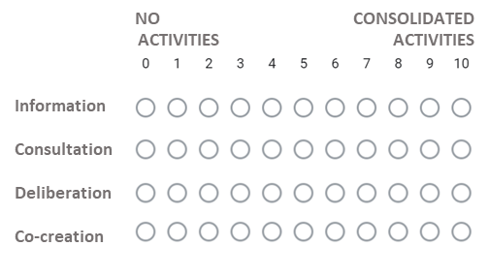
SELECTING TOOLS  Which Approaches and feedback provision mechanisms constitute the citizen engagement strategy? | See TABLE 1 for supporting resources.
ASSESSING CITIZEN ENGAGEMENT SOLUTIONS.  What indicators will you use to assess the progress in objective achievement, engagement, resources, timeline. | E.g list a set of indicators

Figure 1. Template of citizen engagement roadmap

